Title : Ultra-Low Power Smart Logger
Objective :-
Design an ultra-low power ESP32-based environmental logger that can operate in harsh remote conditions like forests, deserts, or glaciers for a minimum of 3 months on a single battery pack.
Sensors & Components :-
ESP32 Development Board - Main microcontroller with Wi-Fi, Bluetooth, deep s sleep support
MicroSD Card Module - Local storage of logged data
BMP280 sensor - Digital temperature and barometric pressure sensor
PIR Sensor - Detects motion to wake up ESP32 from deep sleep
TP 4056 charging Module - Safe battery charging and protection circuit
Lithium ion Battery - Primary power source
Softwares used :-
Kicad - Schematic capture, PCB layout, and electronic design automation (EDA).
Blynk - IoT platform for remote monitoring, visualization, and basic device m a management.
Architecture Diagram :-
TP 4056 charging module
Esp-32 Development Board
SD Card (local memory)
Blynk (cloud storage)
BMP280 sensor
PIR Sensor
Lithium ion Battery

Project Description :-
This project involves designing and building a low-power environmental data logger using the ESP32-DEVKITC-32D development board. The device is intended for remote or outdoor deployments where continuous monitoring of environmental parameters is required but stable power sources are unavailable. The device remains in a low-power deep sleep mode most of the time, waking up either based on a timer or when motion is detected by the PIR sensor. Upon waking, it reads sensor data, logs the data with timestamps on the SD card, uploads the current readings to the Blynk cloud for remote viewing, and runs OTA update checks. After completing its operations, it returns to deep sleep to conserve battery.
- Battery Capacity (C) = 1200 mAh
- Active Current (I_active) = 150 mA
- Active Time (t_active) = 15 seconds = 0.00417 hours
- Sleep Current (I_sleep) = 0.1 mA
- Sleep Time (t_sleep) = 6 – 0.00417 ≈ 5.9958 hours
Average Current Draw:
$$I_{avg}=\frac{I_{active}×t_{active}+I_{sleep}×t_{sleep}}{t_{active}+t_{sleep}}=\frac{(150×0.00417)+(0.1×5.9958)}{6}=\frac{0.6255+0.5996}{6}=\frac{1.2251}{6}=0.2042 \text{mA}$$
Estimated Battery Life: $\text{Battery life (hours)}=\frac{1200}{0.2042}≈5878 \text{hours}$
Convert to days: $\frac{5878}{24}≈245 \text{days}≈8\text{ months}$

Blynk (Cloud Interface):
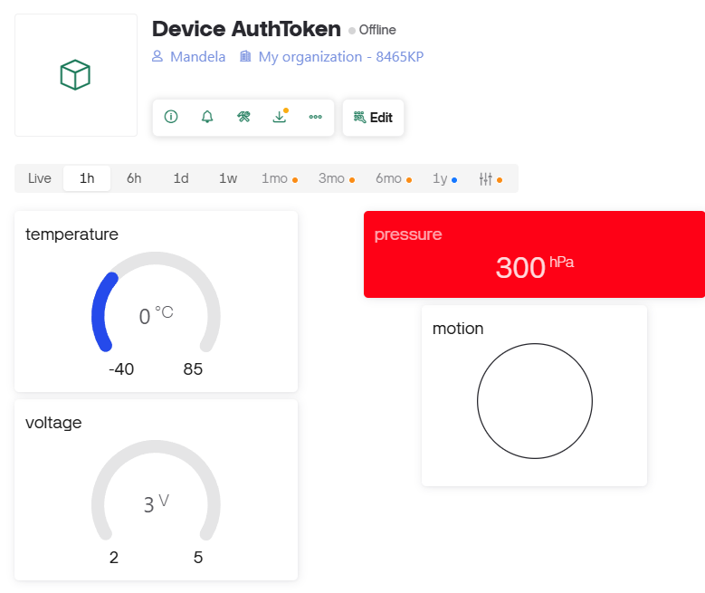

Data Storage format in local storage (SD card) :-
- Date: DD/MM/YYYY, Time: HH:MM:SS, Motion: 0/1,
Temperature: XX.XX celcius, pressure: XXXX.XX, voltage: XX.XXV

- Date: 27/07/2025, Time: 21:00:00, Motion: 0,
Temperature: 25.35 celcius, pressure: 1007.50, voltage: 3.78V

Budget sheet:
component | Price | Product link
SD card reader module | 39rs | https://robu.in/product/micro-sd-card-module/
TP 4056 | 12rs | https://robu.in/product/tp4056-1a-li-ion-lithium-battery-charging-module-with-current-protection-type-c/
PIR motion sensor | 82rs | https://robu.in/product/as312-senba-sensing-tech-plugin-human-body-sensing-sensor-rohs/
ESP – 32  Development Board | 557rs | https://robu.in/product/esp32-wroom-32d-iot-development-doard-module-for-arduino/
BMP 280 sensor | 25rs | https://robu.in/product/bmp280-barometric-pressure-and-altitude-sensor-i2c-spi-module/
Lithium-Ion Rechargeable Battery | 35rs | https://makerbazar.in/products/18650-3-7v-lithium-ion-rechargeable-cell-good-quality?variant=46013701423344

